Overview

This lab will provide an overview of radio buttons and checkboxes. Thus, in this lab we will be: learning the following things:

- Setting up and processing radio buttons
- Setting up and processing check boxes

Exercise 1: Setting Up And Processing Radio Buttons

In HTML, radio buttons are linked together by name. Call two or three different radio buttons the same name, and only one can be selected.

Create a new webpage and enter the following into the webpage:

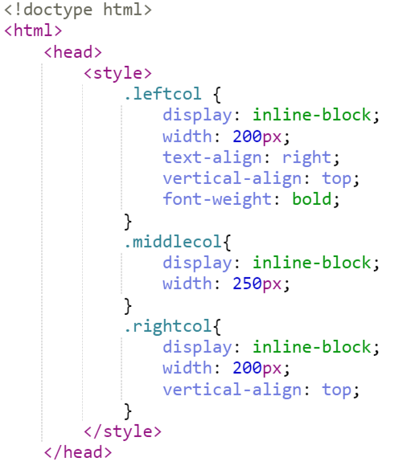
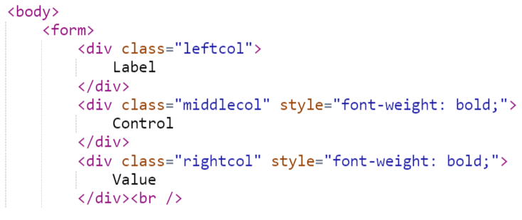
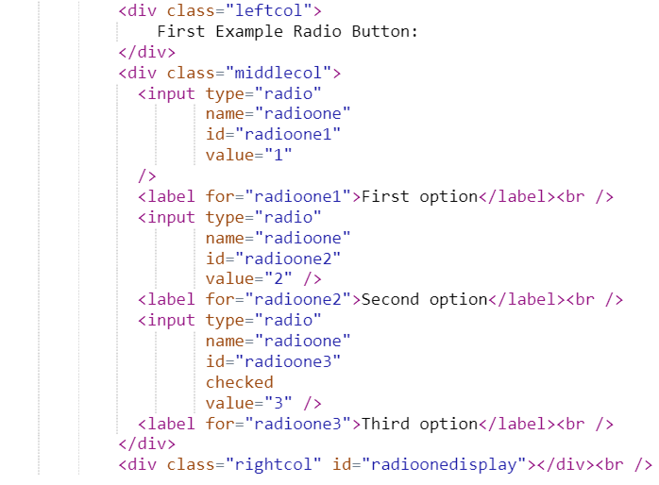
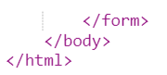

To make a radio button filled on startup, you use the “checked” keyword, rather than (as with pulldowns and listboxes), the word “selected.” Notice how the third radio button is checked.

Run it to see what happens:
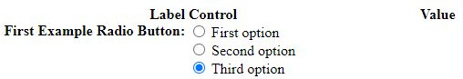

Handling radio buttons on the web is tricky, because the radio control is actually a whole bunch of HTML input statements. To determine the radio button’s value, you have to trawl through all the statements- kind of like how we had to do this for a multiselect listbox.

To complicate matters, a radiobutton is not selected, but is checked. Note that the length of getElementsByName is the number of items with that name.

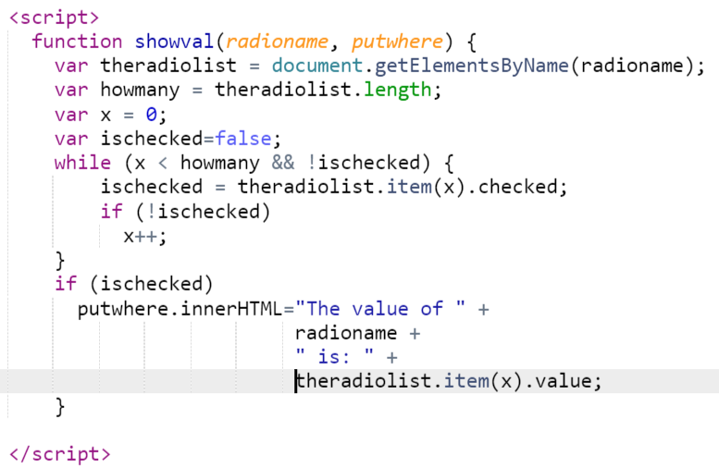
Don’t forget to add this to the radio buttons. You have to add it to every one.

<input type="radio"
name="radioone"
id="radioone1"
value="1"
onclick="showval('radioone',radioonedisplay);"
/>
<label for="radioone1">First option</label><br />
<input type="radio"
name="radioone"
id="radioone2"
onclick="showval('radioone',radioonedisplay);"
value="2" />
<label for="radioone2">Second option</label><br />
<input type="radio"
name="radioone"
id="radioone3"
onclick="showval('radioone',radioonedisplay);"
checked
value="3" />
<label for="radioone3">Third option</label><br />
</div>

Also, add it to the body onload.

<body onload="showval('radioone',radioonedisplay);">

Run the code to see what it does.

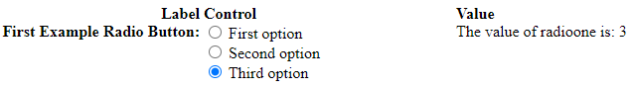

Let’s create two intermingled radio buttons to demonstrate that the name of the radio button is very important:

Put this in the embedded html:

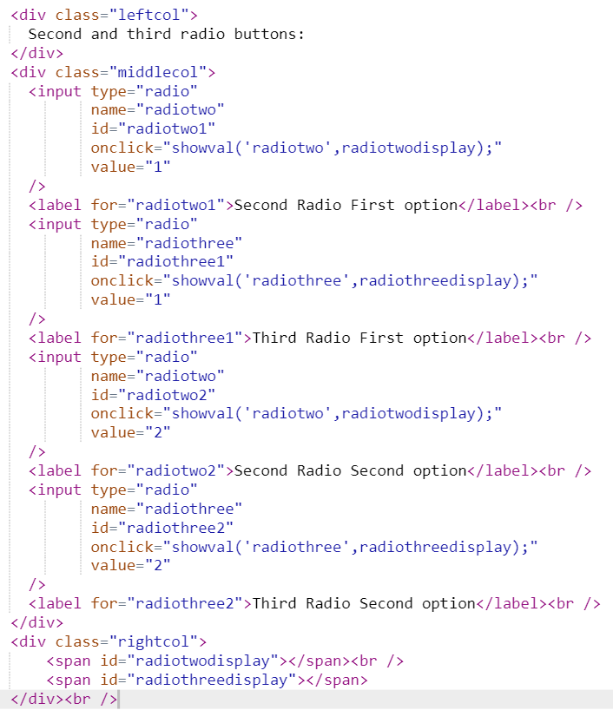
Now try it out:

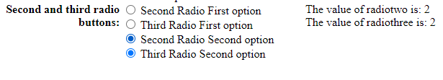

Also, while it often makes sense to make the value of a radio button an integer, it doesn’t have to be. Put the following in the embedded html:

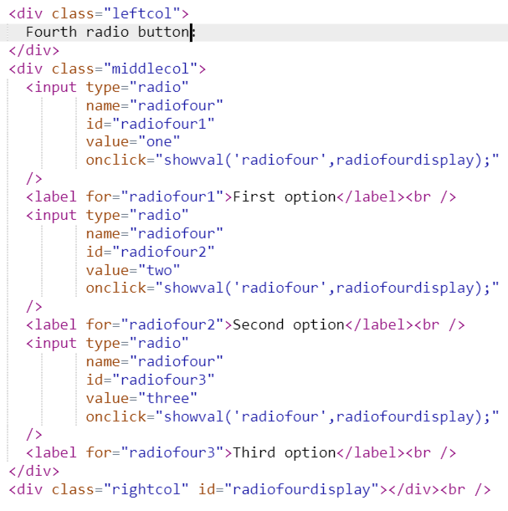

You should get this:

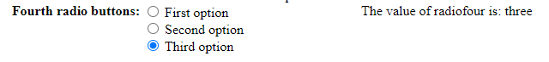

As with listboxes and pulldowns, you sometimes need to generate radio buttons from a database.

Add the following to the HTML:

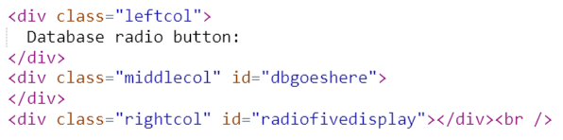
Now make the following AJAX JavaScript function:

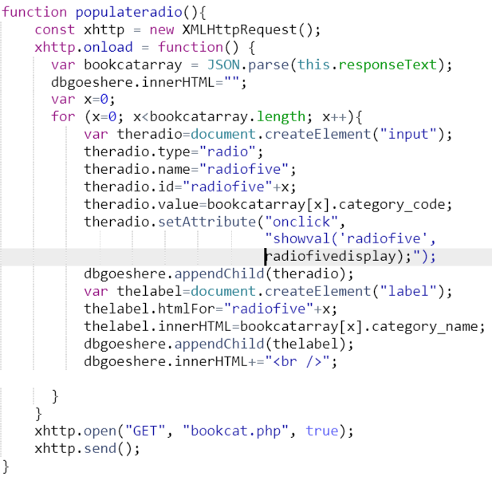
And link it to the onload of the body tag.

<body onload="showval('radioone',radioonedisplay); populateradio();">

The logic is essentially the same as the database display for Week 4, but now adapted to radio buttons.

Again, try out the code to see what it does.
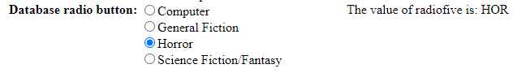

Exercise 2: Setting Up And Processing Check Boxes

Check boxes are essentially the same as radio buttons. However, by convention, we use a check box for yes and no things, rather than for multiple choice.

Here’s a simple check box. In the html, add:

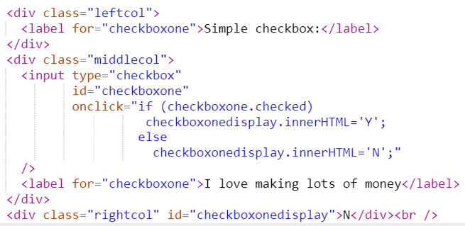
This is what you get:

Notice how we used labels both for the text in front of and behind the checkbox. In this way, one doesn’t have to toggle the checkbox just by clicking on the tiny little square box.

